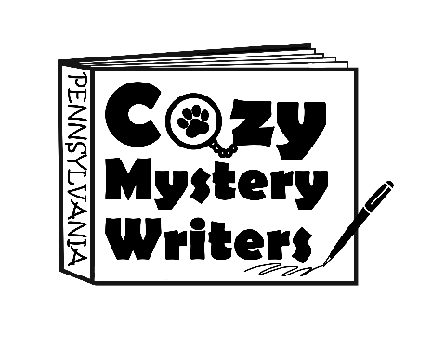
New Book Announcement (Officially On Shelves)
(To Be Posted on the Day of Release)

Congrats on having your new book come out! In order to have your blog post published, please provide the following materials and select three out of the following twelve questions to answer from the next page (this will serve as the bulk of the text). Remember to have fun with your responses!

***While there is no word limit, please keep in mind that readers may be viewing this on a mobile device.

In addition to answering three of the questions, please also send back the following information within this word document:

- Image of the Book Cover (.jpg or .png file format – can be attached to the email if preferred)

- Author Image (if different from what is on our website – can be attached to the email if preferred)

- A short bio (150 words or less – if different from what is already on the website)

- Purchase links for the new book (feel free to include any indie bookshops in your links)

- Back blurb of your new book

- Day to be released (which day you would like your blog post to be published)

- A quote from your book and which character said it.

Questions are continued onto the following page.

Questions:
What was the inspiration behind this new mystery?
Who is your main character and what to do you like about him/her?
Is this book a first in a new series? (If so, please give us a short introduction to the town.)
How does this book differ from your others? Or how is it the same?
Describe one of the local businesses mentioned in your storyline.
Introduce us to two of the side characters that show up in this book.
What was the most fascinating thing you discovered during your research?
Would you want to live inside your storyline? (Please support your answer)
Do you have animal sidekicks in this book? (Please tell us more about them)
Does your book take place in Pennsylvania? (If so, please describe a little)
What is your main character’s favorite thing to eat?
What number in a series is this book, and how have your characters changed over time?

Upon completion, please email the document and all images to:
pacozymysterywriters@gmail.com

For the “Subject Line” of the email: (Book Announcement Blog – Date to be Published) Thanks!

