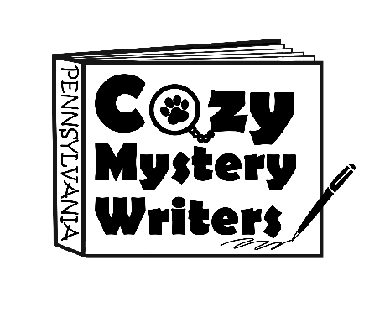
Cover Reveal Announcement!

Congrats on having your new book cover ready to share with the rest of the reading world! In order to have your blog post published, please provide the following materials and select three out of the following twelve questions to answer from the next page (this will serve as the bulk of the text). Remember to have fun with your responses!

***While there is no word limit, please keep in mind that readers may be viewing this on a mobile device.

In addition to answering three of the questions, please also send back the following information within this word document:

- Image of the Book Cover (.jpg or .png file format – can be attached to the email if preferred)

- Author Image (if different from what is on our website – can be attached to the email if preferred)

- A short bio (150 words or less – if different from what is already on the website)

- Back blurb of your new book (if you have it finished)

- Day you would like your blog post to be published

- Day your book will be released (or month)

- One silly fact about you (example: I don’t eat the crust on a peanut butter and jelly sandwich.)

Questions are continued onto the following page.

Questions:
Why did you pick this color scheme for your new cover? (If you didn’t have a say in the matter, tell us what you like about the colors)
How does the front cover relate to your storyline?
Is this book a first in a new series? (If so, please give us a short introduction to what readers can expect.)
What size will your book be? (mass market, trade paperback, hardcover)
Describe to us the setting of your upcoming mystery.
Does this book belong to a series? (If so, please describe a little)
What makes your main character so relatable?
If your main character would read a book, what kind would she/he read?
Does your front cover include any animals? (Please tell us more about their part in the mystery)
Does your book take place in Pennsylvania? (If so, please describe a little)
Is this the first time this story has been published, or is this a reprint? (Meaning that you are republishing them after reacquiring your rights, or that this is a trade or mass market version and was previously printed in a hardcover with different artwork)
What do you find eye-catching in a front cover and how did that influence your decisions when commissioning/creating your own?

Upon completion, please email the document and all images to:
pacozymysterywriters@gmail.com

For the “Subject Line” of the email: (Cover Reveal Blog – Date to be Published) Thanks!

